BPSO iCompute Practice Test

Your Name: _____________________________________

Computing Basics
1. The “short-term memory” that a computer uses while it is running programs to store information that it will need quickly is called __________. This type of memory does NOT retain its contents when the computer is turned off. (2 points)

- Random Access Memory (RAM)
- The Hard Drive
- Read-Only Memory (ROM)
- USB “Thumb” Drive

2. The “long-term memory” that a computer uses to store software programs and data that may be needed in the distant future is called _________. This type of memory retains its contents even when the computer is turned off. (2 points)

- Random Access Memory (RAM)
- The Hard Drive
- A Monitor
- The Motherboard

3. Which of the following CPUs speeds would be the fastest? (2 points)
- 300 MHz
- 2 GHz
- 12 Parsecs
- 1.2 MHz

4. Name three components that you would find inside a computer. (2 points)
[Note: a “component” can be a part of the computer or a separate device.]

Good Answers: | OK Answers:
CPU  Motherboard  Hard drive  RAM/Memory  Graphics/Video Card/GPU  Power Supply  Network card | USB Port  Video Port  Ethernet Port  “Wires”

5. What is another name for a “set of instructions,” stored on a computer, that can tell computer hardware what to do”? (2 points)
- Manual
- Software
- Flowchart
- Checklist

Theoretical Computing

7. Fill in the blank cells in the table below (5 points) [You can use this area for work]

Binary | Decimal
10 | 2
101 | 5
100011 | 35
11100010 | 226
11101000 | 232
1111+1 | 16

8. Refer to the flowchart labeled “Practice Test Mystery Algorithm.” (5 points total for A and B)

A. Describe in a sentence or two what this algorithm does.

It finds the largest number in a list.

B. What would the output at point B be if a user input the list “10 4 15 3 2” at point A?

15

9. You have a pile of coins, consisting of pennies, nickels, dimes, and quarters. You need to sort all the coins in the pile into four bags: pennyBag, nickelBag, dimeBag, and quarterBag. Complete the flowchart labeled “Coin Sorting Algorithm” to show a process that will perform this task correctly. (5 points)

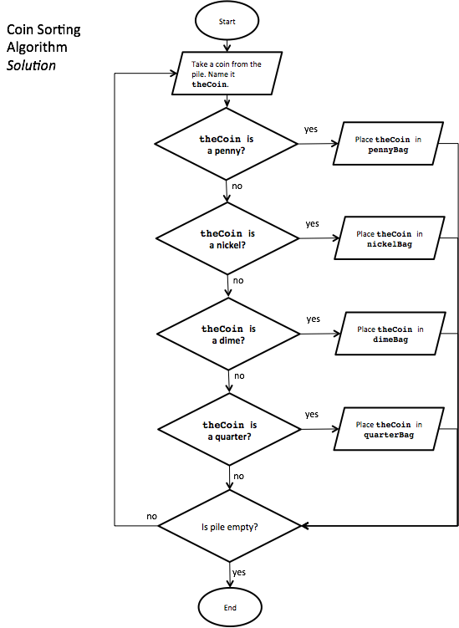

Practical Computing

10. Create a guessing game in Scratch. When started, your game should choose a random number between 1 and 10 and keep it secret from the player. After each guess, the game should tell the player if the secret number is higher, lower, or equal to the guess. The game is over when the player guesses correctly. Share your project with a title indicating that it’s a guessing game. (30 points)

o 10 points for a correct algorithm that uses proper programming constructs
o 10 points for a working program
o 5 points for attention to precision
o 5 points for creativity and/or efficiency (tie-breaker)

See numerator’s example solution at https://scratch.mit.edu/projects/106108476/

Bonus
Only after finishing everything else

Create a “tag” game in Scratch. A character moves around the screen, and when the player clicks on the character, the character says “I’m it.” After “tagging” the character the first time, make a new, harder (but still playable) level where the character is harder to tag.

No example solution provided for this one. It was just to keep you busy in case you finished early!

